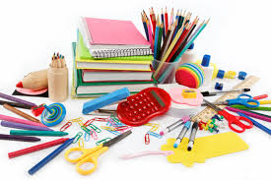
ᷘ☐☐☐6th GRADE SUPPLY CHECKLIST 2022-2023

⃞⃞᷑᷑᷑᷑᷑᷑᷑᷑᷑ᷥ᷼ ☐ ear buds or head phones to leave at school (please label student’s name)
EVERY STUDENT MUST HAVE THEIR OWN!
☐ pens/pencils/erasers (4 boxes - 1 for each marking period)
☐ Twistable colored pencils
☐ Glue Sticks (3)
☐ large pencil pouch (to hold all the items on this list/to be carried to all classes)
☐ highlighters
☐ loose leaf paper
☐ TI-30XIIs scientific calculator (not needed until April)
☐ Safety Glasses (not goggles, or $2 if you want to purchase from Mrs. Horton)
☐ $3 lab fee (add $2 if you would like Mrs. Horton to purchase safety glasses)

Qty Item
☐ 2 blue poly (plastic) folders for math; 2 pocket with prongs

☐ 2 green poly (plastic) folders for science; 2 pocket with prongs

☐ 2 purple poly (plastic) folders for social studies; 2 pocket with prongs

☐ 1 yellow poly (plastic) folders for ELA; 2 pocket with prongs

☐ 1 folder (any color) for Special Area classes (art, music, FACS, CTE)

NOTE: WATCH FOR THE SCHOOL SUPPLY SALES AT TARGET, WAL-MART, STAPLES, ETC.
PLEASE SEND YOUR CHILD IN WITH ALL THEIR SUPPLIES THE FIRST DAY OF SCHOOL!

